How to Adjust Your Glasses
Are you facing problems or issues related to the adjustment of your eyewear? Don’t worry sit back and relax we got you covered! Read our hints below to easily solve the common eyewear adjustment problems.
Common Problems
- The glasses are sitting on lower position on the nose.
- Pinching on the nose due to glasses
- The positions of a lens are not correct one is higher from other or one lens is closer to the eye as compared to other.
Types of Frame
Glasses are present in plastic, metal frame. Wire frame is also available.
Solutions
The solution to problem related to metal, plastic and wire frame are outlined below:
Plastic/ Acetate Frame
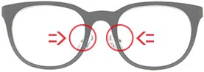

- If your glasses are sitting too low on your nose, push the nose pads closer together until you get the desired fitting by use of your thumbs.
Metal/Wire Frame
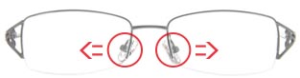

- If your glasses are TOO HIGH, gently push out on the plastic nose pad. Do this on both sides until they sit at the desired height.
Plastic/ Acetate Frame
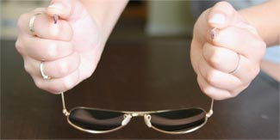

- To correct the position of the frame on nose, use a hairdryer for 30 seconds over the part of the frame you want to bend to make it softer. After this bend inward at bridges, hinges, or temple arm to make the frame fit you comfortably and closely.
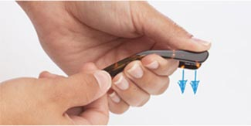

- To overcome the pinching, use a hair dryer for 30 seconds until they are pliable and bend the nose pieces outward slowly to make it fir for use.
Lenses Position
To solve the problem related to lenses position either they are higher or closer. Four common scenarios are addressed below:
If Right lens is Higher, bend the left arm of your glasses where it can be adjusted well: at the position of hinge or you may bend at your ear.
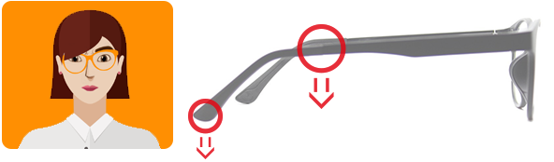

If Left lens is Higher, bend the right arm of your glasses down where it can be adjusted well: at the hinge or you might bend at you ear.
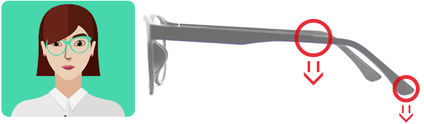

If Right Lens is Closer, bend the right arm of eyeglasses in or you can bend the left arm out at the hinge position.
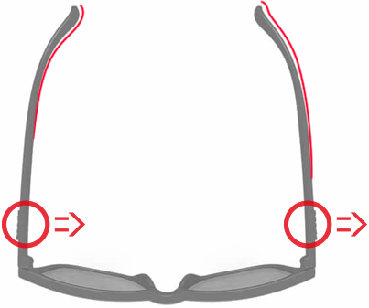

If Left Lens is Closer, bend the left arm of eyeglasses in or you can bend the right arm at the hinge position.
